1. 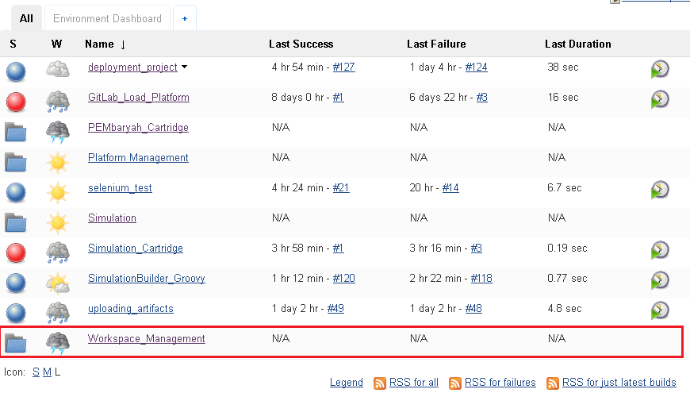Click Workspace_Management
2. 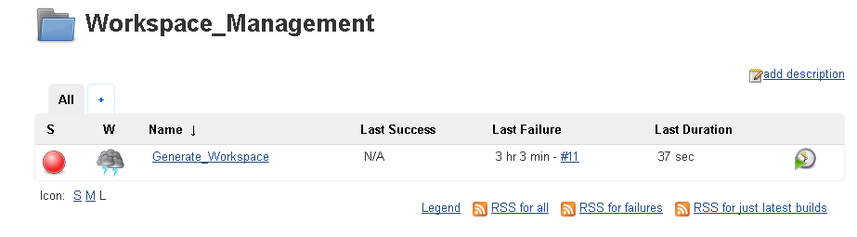Click Generate_Workspace
3. 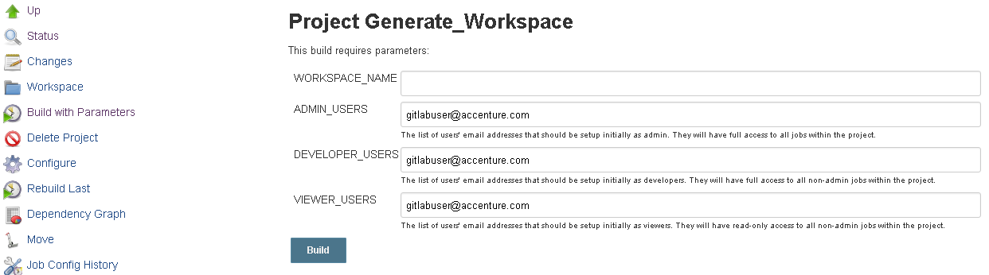Click **Build with Parameters** and enter the desired name of the cartridge.
4. 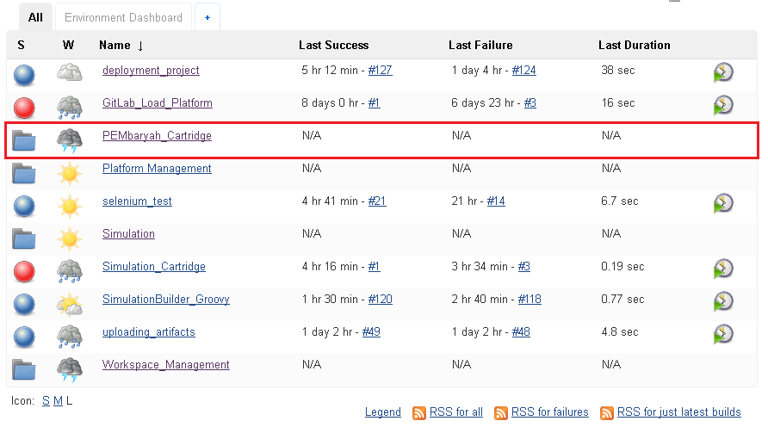Go back to the Jenkins Dashboard and click the generated workspace of the cartridge.
5. 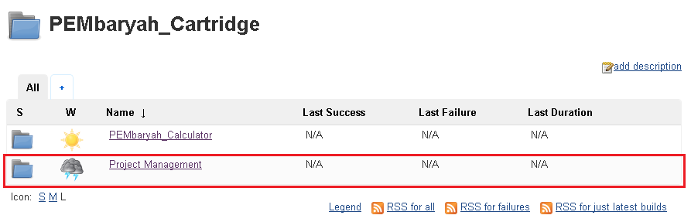Click *Project_Management*.
6. 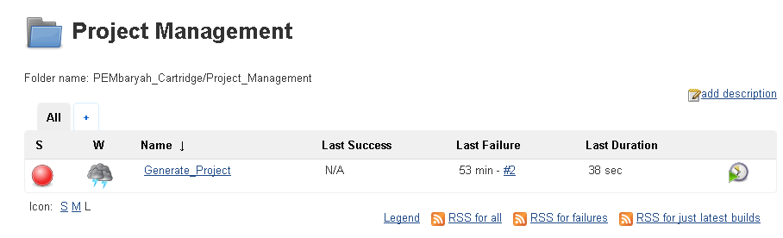Select *Generate_Project* Job.
7. CLick *Build with Parameters* on the left side of the page and enter the desired project name. Click *Build* when done to save and build simultaneously.

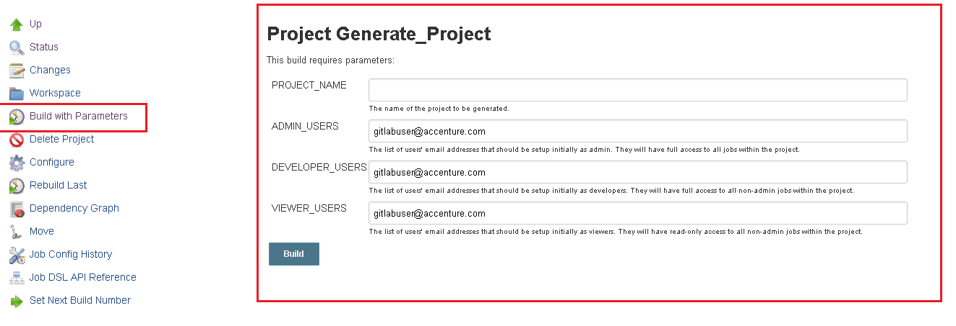

1. 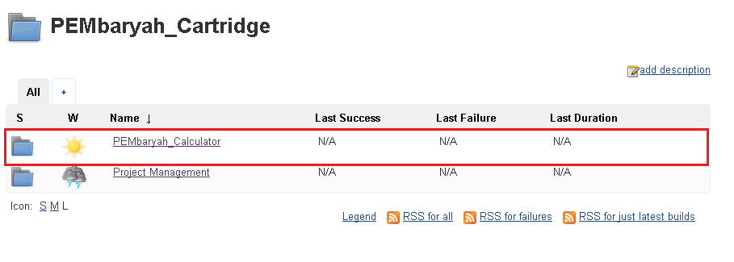Then click the new generated workspace *(PEMbaryah_Calculator)* on the same location with the previous workspace *(Project_Management)* and the workspace inside of it *(Cartridge Management).*
2. 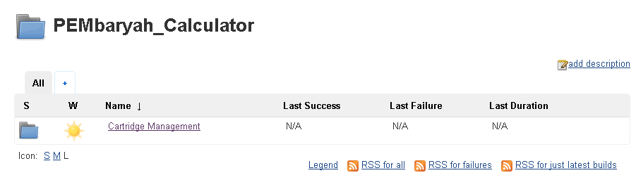Click the new generated job.

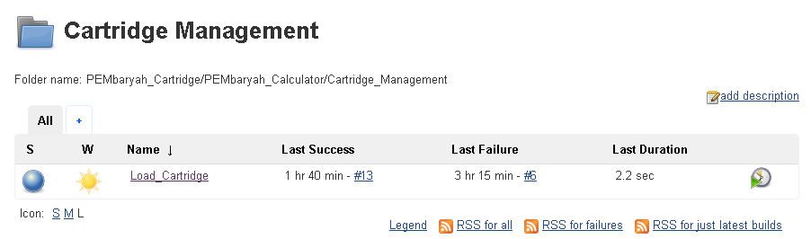

1. 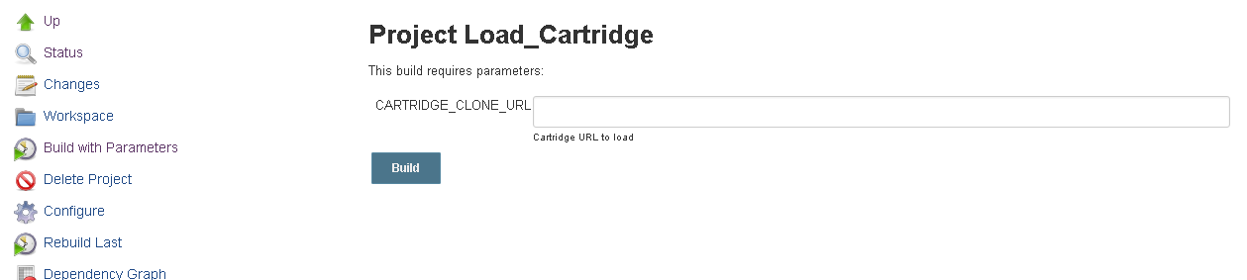Click the Build with Parameters and paste the URL of the groovy file from the source code repository. Click Build when done. It will create a new workspace in Jenkins dashboard based on the cloned groovy file.

CARTRIDGE_CLONE_URL format : **https://username:password@ip/---------.git**

1. 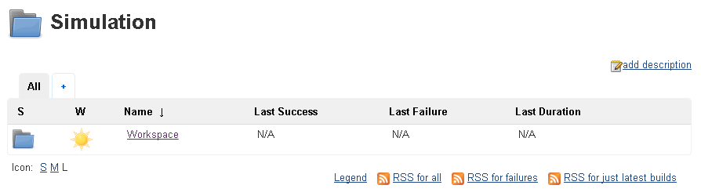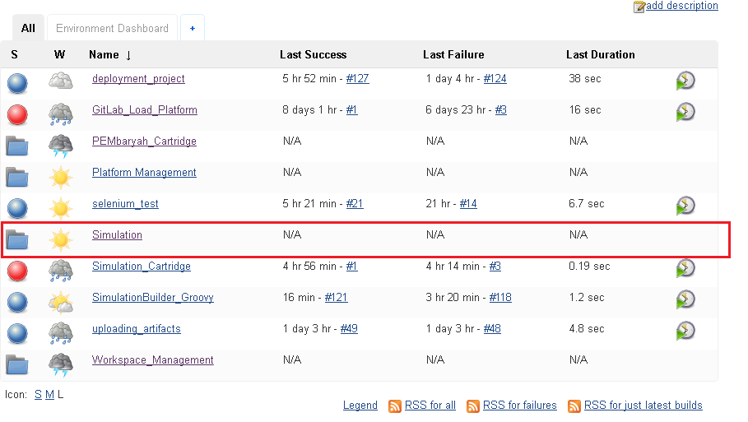Click the latest workspace created. It will contain another workspace that contained the jobs that will be used in pipeline.
2. 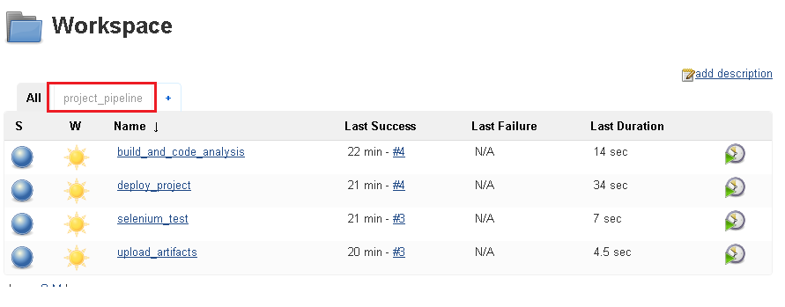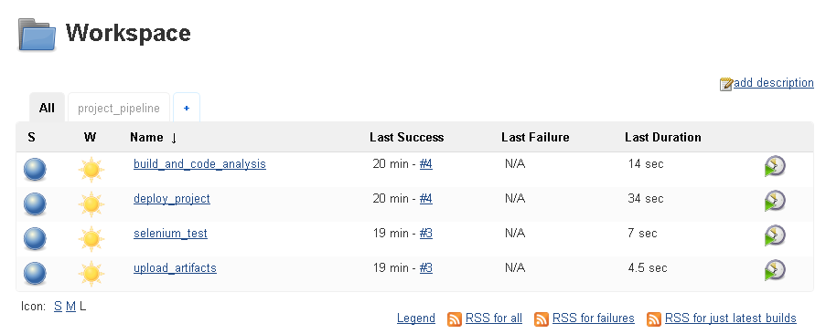Click the *project_pipeline* tab to view the pipeline.
3. 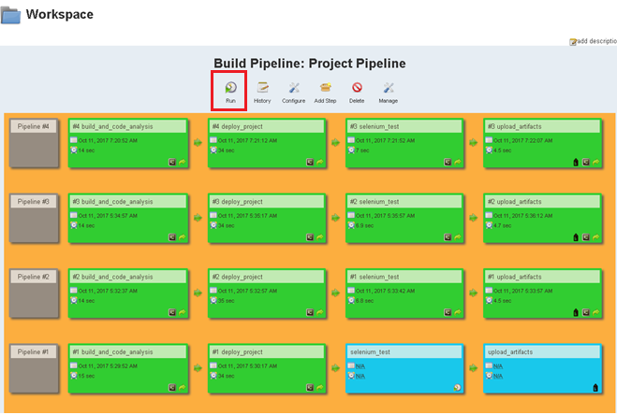Click *Run* to start the jobs.